Theory:
Linear convolution and circular convolution are mathematical operations used to combine two signals to obtain a third signal. They are widely used in various applications, such as signal processing, image processing, and audio processing.

Linear convolution calculates the sum of element-wise products of two signals, considering the full range of valid indices. It is typically used for finite-length signals and can produce an output signal that is longer than the input signals.

Circular convolution, on the other hand, calculates the sum of element-wise products of two signals, considering a periodic extension of the input signals. It is commonly used for periodic or infinite-length signals and produces an output signal with the same length as the input signals.

Convolution is a mathematical operation used to combine two discrete-time signals and generate a new signal. It is widely used in Digital Signal Processing (DSP), communication systems, image processing, and audio processing for filtering, signal analysis, and system response.

There are two main types of convolution:
Linear Convolution calculates the complete overlap between two finite-length signals. The output length is N + M − 1, where N and M are the lengths of the input signals. It is commonly used for non-periodic (finite) signals.

Circular Convolution assumes that the input signals are periodic (repeat continuously). It is usually computed using the Fast Fourier Transform (FFT) and Inverse Fast Fourier Transform (IFFT), producing an output whose length is equal to the chosen FFT length (generally the maximum length of the input signals).

In this experiment, both linear and circular convolution are computed for two discrete-time signals using NumPy functions, and the results are displayed graphically using Matplotlib to compare their behavior.

Flowchart:
The flowchart for the program will consist of the following steps:

Define two discrete-time signals (signal 1 and signal 2).
Compute the linear convolution of the two signals using numpy.convolve. Compute the circular convolution of the two signals using numpy.fft.ifft. Plot and display the linear and circular convolution results.
Save the linear and circular convolution results (optional).
Now, let's see the Python program that simulates linear convolution and circular convolution on discrete-time signal

import numpy as np
import matplotlib.pyplot as plt

def linear_convolution(signal1, signal2): # Compute the linear convolution
linear_conv = np.convolve(signal1, signal2, mode='full') return linear_conv

def circular_convolution(signal1, signal2): # Compute the circular convolution
# Compute the circular convolution If( len(signal1) > len(signal2) ): fft_length=len(signal1);
else: fft_length=len(signal2);
fft_signal1 = np.fft.fft(signal1, fft_length) fft_signal2 = np.fft.fft(signal2, fft_length) circular_conv = np.fft.ifft(fft_signal1 * fft_signal2) return circular_conv

# Define the discrete-time signals signal1 = np.array([1, 2, 3, 4, 5])
signal2 = np.array([2, 4, 6, 8, 10])

# Compute the linear convolution
linear_conv = linear_convolution(signal1, signal2)

# Compute the circular convolution
circular_conv = circular_convolution(signal1, signal2)

# Plot the linear and circular convolution results plt.figure(figsize=(10, 6))
plt.subplot(2, 1, 1) plt.stem(linear_conv) plt.title('Linear Convolution') plt.xlabel('Sample') plt.ylabel('Amplitude')

plt.subplot(2, 1, 2) plt.stem(circular_conv) plt.title('Circular Convolution') plt.xlabel('Sample') plt.ylabel('Amplitude')

plt.tight_layout() plt.show()

# Save the linear and circular convolution results (optional)
# np.savetxt('linear_convolution.txt', linear_conv, delimiter=',')
# np.savetxt('circular_convolution.txt', circular_conv, delimiter=',')

Explanation:
In this program, we compare Linear Convolution and Circular Convolution of two discrete-time signals. Before understanding the program, it is important to know what convolution means.
Convolution is a mathematical operation used to combine two signals and produce a new signal. It is widely used in Digital Signal Processing (DSP), communication systems, image processing, audio processing, filtering, and many other engineering applications. Depending on how the signals are processed, convolution is divided into two types:
- Linear Convolution
- Circular Convolution
The purpose of this program is to calculate both types of convolution for two input signals and display their outputs using graphs.

Step 1: Import the Required Libraries
import numpy as np
import matplotlib.pyplot as plt
The program begins by importing two Python libraries.
- NumPy (numpy) is used for mathematical operations on arrays. It provides built-in functions such as np.convolve(), np.fft.fft(), and np.fft.ifft() which make convolution calculations very easy.
- Matplotlib (matplotlib.pyplot) is used for plotting graphs so that we can visually compare the results of linear and circular convolution.
Without these libraries, we would have to manually perform all calculations and graph plotting, which would be much more complicated.

Step 2: Define the Function for Linear Convolution
def linear_convolution(signal1, signal2):
linear_conv = np.convolve(signal1, signal2, mode='full')
return linear_conv
Here, a function named linear_convolution() is created.
This function accepts two input signals:
- signal1
- signal2
Inside the function,
np.convolve(signal1, signal2, mode='full')
is used.
The np.convolve() function performs linear convolution automatically.
The parameter:
mode='full'
means that all possible overlapping positions of the two signals are considered.

For example,
If
signal1 = [1,2,3]
signal2 = [4,5]
the output length becomes
3 + 2 - 1 = 4
So linear convolution always produces an output whose length is
Length of Signal1 + Length of Signal2 − 1
Finally,
return linear_conv
returns the calculated convolution to the main program.

Step 3: Define the Function for Circular Convolution
def circular_convolution(signal1, signal2):
Now another function is created to perform Circular Convolution.
Unlike linear convolution, circular convolution assumes that the signals repeat forever (periodic signals).
Instead of directly using np.convolve(), this program uses the Fast Fourier Transform (FFT) because circular convolution can be calculated efficiently in the frequency domain.

Step 4: Decide the FFT Length
if(len(signal1) > len(signal2)):
fft_length = len(signal1)
else:
fft_length = len(signal2)
FFT requires both signals to have the same length.
Therefore, the program checks which signal is longer.
If signal1 is longer,
fft_length = len(signal1)
Otherwise,
fft_length = len(signal2)
The larger length is chosen.
If one signal is shorter, NumPy automatically pads it with zeros while computing the FFT.

Step 5: Compute FFT of Both Signals
fft_signal1 = np.fft.fft(signal1, fft_length)
fft_signal2 = np.fft.fft(signal2, fft_length)
Here,
np.fft.fft() converts each signal from the time domain into the frequency domain.
The FFT (Fast Fourier Transform) is an efficient algorithm used to calculate the Discrete Fourier Transform (DFT).
Instead of multiplying signals directly in the time domain, convolution becomes much easier in the frequency domain.
After this step,
- fft_signal1 contains the frequency representation of the first signal.
- fft_signal2 contains the frequency representation of the second signal.

Step 6: Multiply Both FFTs
fft_signal1 * fft_signal2
One of the most important properties of Fourier Transform is:
Convolution in the time domain is equivalent to multiplication in the frequency domain.
Therefore, instead of performing convolution directly, we simply multiply the FFTs of both signals.
This multiplication is done element by element.

Step 7: Convert Back to Time Domain
circular_conv = np.fft.ifft(fft_signal1 * fft_signal2)
The multiplication result is still in the frequency domain.
To obtain the actual circular convolution signal, we apply
np.fft.ifft()
where IFFT means Inverse Fast Fourier Transform.
The IFFT converts the frequency-domain result back into the time domain.
The output obtained is the circular convolution.
Finally,
return circular_conv
returns the circular convolution result.

Step 8: Define the Input Signals
signal1 = np.array([1,2,3,4,5])
signal2 = np.array([2,4,6,8,10])
Now two discrete-time signals are created.
First signal:
[1,2,3,4,5]
Second signal:
[2,4,6,8,10]
These arrays act as the input signals for both convolution operations.
You can replace these values with any other signals to observe different outputs.

Step 9: Compute Linear Convolution
linear_conv = linear_convolution(signal1, signal2)
The program calls the previously defined function.
It passes both signals to the function.
The function calculates the complete linear convolution using np.convolve().
The returned result is stored in
linear_conv

Step 10: Compute Circular Convolution
circular_conv = circular_convolution(signal1, signal2)
Similarly, the circular convolution function is called.
Inside the function,
- FFT is calculated.
- Both FFTs are multiplied.
- IFFT is applied.
The final circular convolution is stored in
circular_conv

Step 11: Create a Figure
plt.figure(figsize=(10,6))
A figure is created to display graphs.
The figure size is
- Width = 10
- Height = 6
This provides enough space for both graphs.

Step 12: Plot Linear Convolution
plt.subplot(2,1,1)
plt.stem(linear_conv)
plt.title("Linear Convolution")
plt.xlabel("Sample")
plt.ylabel("Amplitude")
Here,
subplot(2,1,1)
means
- Total rows = 2
- Total columns = 1
- Display the first graph.
Since signal processing deals with discrete signals, stem() is used instead of plot().
The graph shows
- X-axis → Sample Number
- Y-axis → Amplitude
The graph title is
Linear Convolution

Step 13: Plot Circular Convolution
plt.subplot(2,1,2)
plt.stem(circular_conv)
plt.title("Circular Convolution")
plt.xlabel("Sample")
plt.ylabel("Amplitude")
Now the second graph is drawn.
subplot(2,1,2)
means
- Second graph
- Same figure
Again,
stem() is used because the signal is discrete.
The graph title becomes
Circular Convolution
Now both graphs can be compared easily.

Step 14: Display the Graphs
plt.tight_layout()
plt.show()
plt.tight_layout() automatically adjusts the spacing between the graphs so that labels and titles do not overlap.
plt.show() displays the final output window containing both graphs.

Step 15: Save the Results (Optional)
# np.savetxt('linear_convolution.txt', linear_conv, delimiter=',')
# np.savetxt('circular_convolution.txt', circular_conv, delimiter=',')
These lines are currently commented out.
If you remove the # symbol, the program will save both convolution results into separate text files.
For example,
linear_convolution.txt
contains the linear convolution output.
Similarly,
circular_convolution.txt
contains the circular convolution output.
This is useful if you want to analyze the output later or use it in another program.

Expected Output:

A plot will be displayed showing the linear and circular convolution results. The linear and circular convolution results will be saved to text files (optional).
Feel free to experiment with different discrete-time signals and observe the linear and circular convolution outputs.
A figure window is displayed containing two stem plots:
Linear Convolution of the two input signals.
Circular Convolution of the same signals.
The Linear Convolution output contains 9 samples (N + M − 1), while the Circular Convolution output contains 5 samples (equal to the chosen FFT length).
If the np.savetxt() lines are uncommented, the convolution results are saved as:
linear_convolution.txt
circular_convolution.txt
This allows you to visually compare the results of linear and circular convolution and optionally store the outputs for later use.

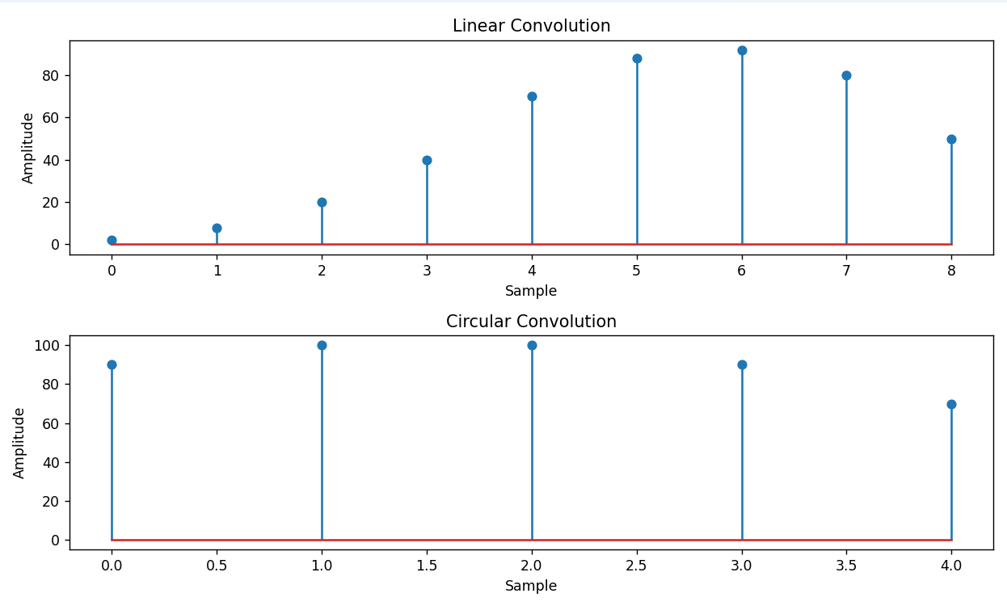

Conclusion
The program successfully demonstrates the implementation of Linear Convolution and Circular Convolution using Python on two discrete-time signals. Linear convolution computes the complete overlap between the signals and produces an output of length N + M − 1, whereas circular convolution assumes the signals are periodic and generates an output based on the chosen FFT length. The use of NumPy simplifies the convolution calculations, while Matplotlib provides a clear graphical comparison through stem plots. By observing the outputs, the difference between linear and circular convolution becomes easy to understand. This experiment provides practical knowledge of convolution techniques and highlights their importance in Digital Signal Processing (DSP), communication systems, and signal analysis.

